Англійська мова

Завдання з дистанційного навчання групи №34
Підсумок «Читання»
Прочитати та перекласти текст
The monster.

At different times, thousands of people say that they have seen a large animal in the famous lake called Loch Ness in Scotland. For many centuries, people have tried to catch it. People who live there always talk about the mysterious animal in the lake, and many of them believe that it is still there today.
In 1933, John McGregor, a local businessman, saw that the lake began to bubble, and a huge animal with two humps came out of it.
After that, scientists examined the lake with underwater equipment and tried to find out what kind of animal lived there. Of course, they haven’t found it yet, because the lake is so deep and so dark.
Tourists from all over the world have visited Loch Ness, they hope to see the monster. They have even given it a nickname “Nessie”. Many people even show photos of the monster, but they are usually photos of the pictures of the monster. Scientists suppose that the Loch Ness monster is a dinosaur, which has survived since the Ice Age.
Here is a description of the monster:
- Length: About 50 metres.
- Body: With two humps.
- Half horse, half snake and quite small.
- Long and thin, like a giraffe.
- Yellow-brown.
- People think that it eats sheep on land and underwater plants.
- Shy, doesn’t want to be seen.
- Lives in the deepest and coldest parts of the lake about 1 km from the surface.
Завдання до тексту.
Exercise 1. Insert the words according to the text.
have visited, haven’t found, tried, so deep and so dark, came out of it
• For many centuries people … to catch it.
• The lake began to bubble and a huge animal…
• Of course they … it yet.
• The lake is ……
• Tourists from all over the world … Loch Ness.
Exercise 2. Виберіть правильну кінцівку для пропозицій.
• Loch Ness is in …
• England b) Scotland c) Wales
• Loch Ness is …
• a lake b) a river c) a village
• Scientists examined the lake with
• a) underwater equipment c) computers d) special ultrasound gadgets
• Tourists have given the monster a nickname
• Locky b) Nessie c) Lohnessi
Exercise 3. True or false.
• For many centuries, people have tried to catch the Loch Ness monster.
• No one believes that the Loch Ness monster is still in the lake today.
• In 1956, John McGregor, a local businessman, saw that the lake began to bubble.
• The lake is very deep.
• Many people show photos of the monster.

Exercise 4. Доповніть опис Лохнеського чудовиська.
- Length: About _______ (1)
- Body: With two humps.
- Half __________ (2), half snake and quite small.
- Long and thin, like a giraffe.
- Yellow-brown.
- People think that it eats __________ (3) on land and underwater ________ (4).
- Shy, doesn’t want to be seen.
- Lives in the deepest and __________ (5) parts of the lake about 1 km from the surface.

Завдання з дистанційного навчання групи №11
Тема: « Винаходи та винахідники»
Прочитати та перекласти текст
Topic: Many people say that the internet is the most important invention ever. Do you agree or disagree with this and if not, what do you believe to be more important. Use specific reasons and examples to support your opinion.
Thirty years ago no one could ever imagine that such thing as the internet will be invented. Nowadays, life without internet for the most people is unimaginable. It is rooted in our communication and banking. Some people consider the internet as the most important invention ever. My personal opinion is that every invention has its time, and the internet is the greatest invention of our time. I will support my theory in the following paragraphs.
Firstly, the internet provides enormous amount of information. Everyone can find all types of information on millions of topics. That way they can find data for their work or school projects. Also, people are able to find information on every subject they are interested in. Moreover, with searching engines like “Google” and “Yahoo Search” it’s even easier for them to find the exact information they are looking for. However, this easy access to so much information can sometimes be dangerous. For example, someone could search the web to find a way to build a bomb. This kind of information, if not in the right hands, can be very dangerous.
Secondly, people are using the internet for communication. People can participate in social networks like “Facebook” or “Twitter”. Also, there are millions of chat rooms and even dating sites. Communication through the internet is easy and available to everyone with a computer. With it, people can keep in touch with their friends in distance, or make new ones. Nevertheless, this way of communication can sometimes be inefficient. Face-to-face conversation, atleast in my opinion, is much better.
Last but not least, I want to say that the invention of the internet could not be even possible without some earlier inventions and discoveries. As I said above every invention has its time. First it was the discovery of fire, then the invention of the wheel. Later it was the electricity, the telegraph and the computer. All this led to the invention of the internet.
It can be concluded that, there are many great inventions, every one of them important for its time. The internet, even with its flaws, is the most important invention of our modern time.

Виконати завдання
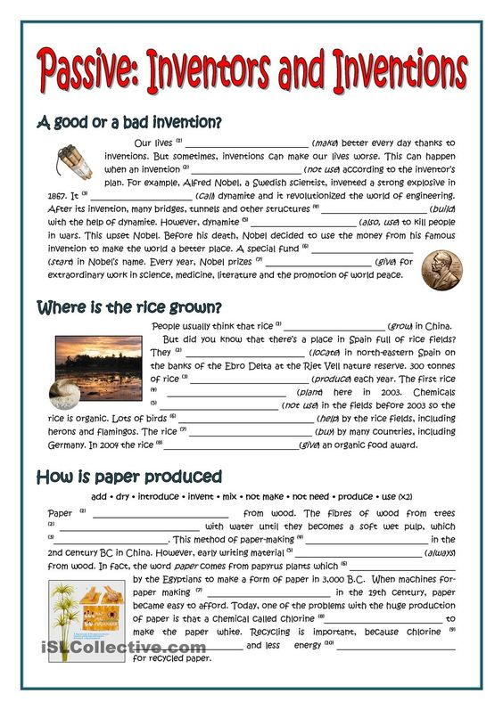

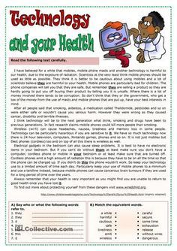

Завдання з дистанційного навчання групи №12
Тема: « Мистецтво»
ПРОЧИТАТИ ТА ПЕРЕКЛАСТИ ТЕКСТ
Some people claim that the world nowadays is too «materialistic». People sometimes fail to appreciate the beauty which surrounds us everywhere. They are too obsessed with, as they say, «real problems». Unfortunately, if you tell them to stop and look around, they’ll think you’re just laughing at them. «Can’t you see I’m busy? Staring at things can’t give me any money!» — will be the answer.
But all of us shouldn’t forget the human personality is a fivefold constitution (a body, a life, a mind, a psychic and a spiritual being). None of these elements stands disconnected from the others. It’s good to climb a career ladder as fast as possible and become prosperous. But don’t forget about your soul — treat it to some art.
In my opinion art plays a great role in the development of the spiritual world of every human being. Art helps to see things from another point of view, it elevates the mind and soul, it helps to develop a good taste. I think it’s very important that talented artists manage to capture and represent such an intangible thing as the mood. Thus the beholder not only gets information about the subject matter of the canvas but also he is able to understand the artist’s attitude to it. And we should agree that a good painter should involve beholders into his creative process. T mean that while painting the artist just gives us some clues, hints better to understand his message but only a very careful art-lover will understand them completely.

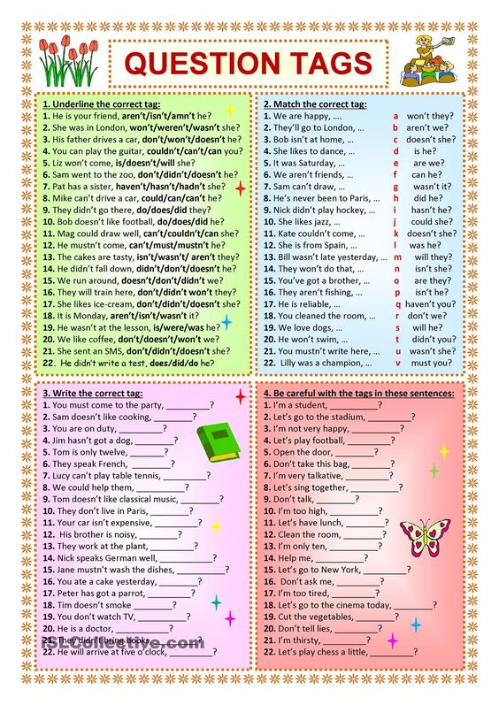

Завдання з дистанційного навчання групи №23
Тема: « Захист навколишнього середовища»
ПРОЧИТАТИ ТА ПЕРЕКЛАСТИ ТЕКСТ

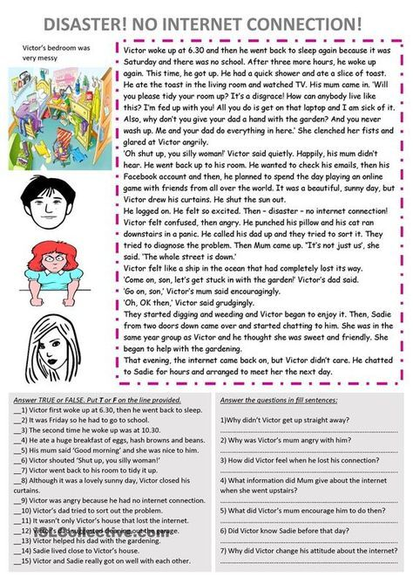

Виконати завдання: Прочитати та зробити тести
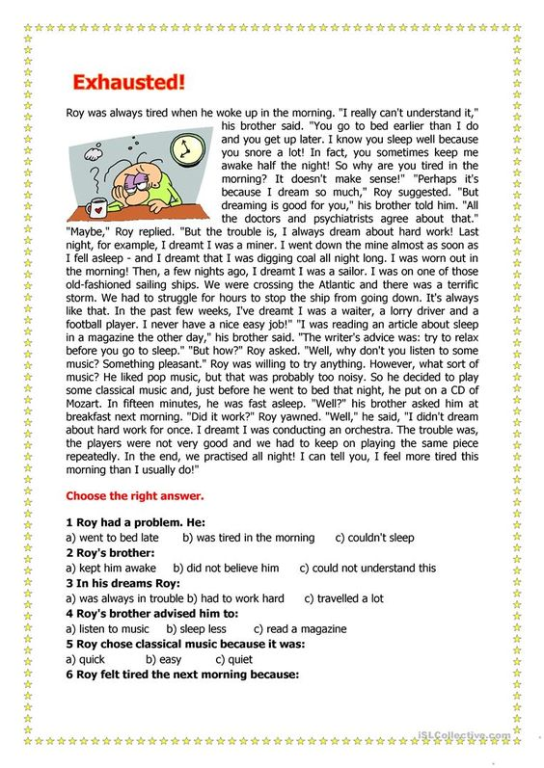

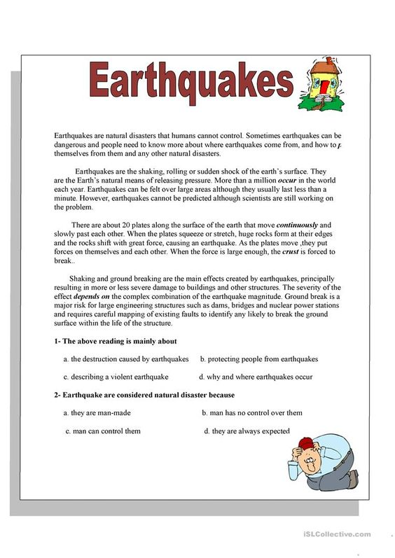

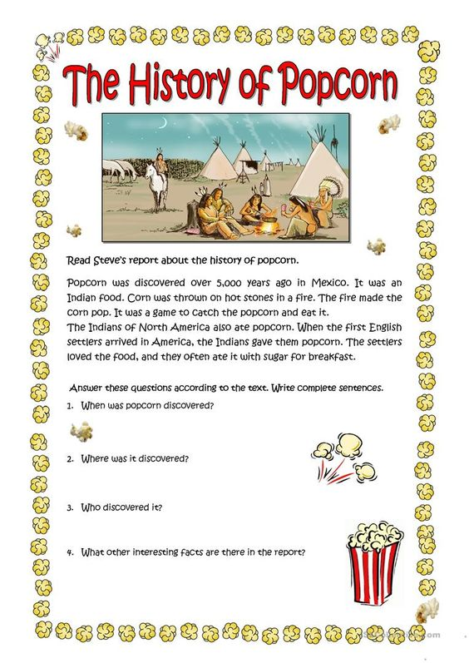

Завдання з дистанційного навчання групи №14
Тема: «Професії»
ПРОЧИТАТИ ТА ПЕРКЛАСТИ ТЕКСТ


Прочитати
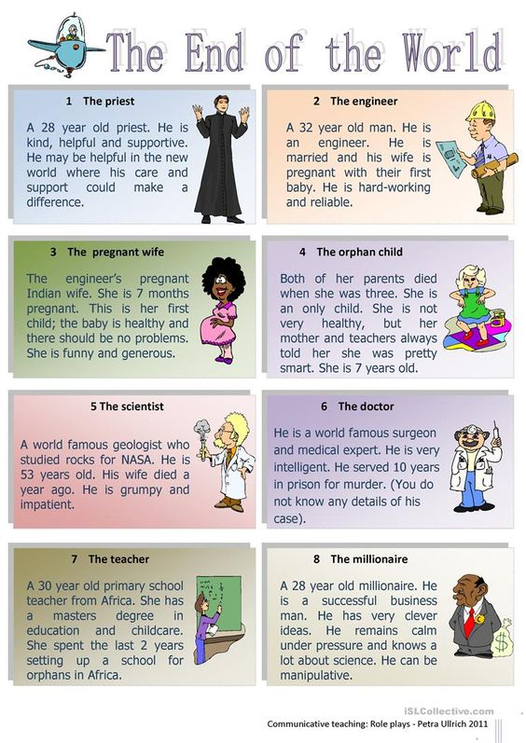

Виконати завдання
