Завдання з дистанційного навчання групи №24



Music in the Streets
As you go home after a hard day’s work, and you get off the metro train, sometimes you have to walk a long way to the exit or to change trains. Suddenly in the noise, some music is heard. Those are street musicians. You take out a coin from your pocket and throw it into their hat or instrument case. These musicians bring color and life to the city streets. Street musicians are aged between 17 and 30 years. Some of them are men, some women. They play classical music, pop or folk music, old and new songs. Many musicians are former university students or professional musicians.
Andrew Hain, for example, was once a music student, but he gave up music and became a painter. Now he plays in the underground because he doesn’t want to forget how to play. His girlfriend is a painter, too. She helps him to collect the money. Another street musician, David MacNell, tells new players:
“Learn new songs all the time, or else you’ll have fewer and fewer listeners. Wear bright clothes to attract attention. Make sure that the places where you choose to play are warm. The best places are and bridges certainly the underground.”
On Sundays, Hyde Park is the best place as the speakers here address the people. The street musicians are doing business with their the many tourists who visit the park. The weather is one of the worst problems. It is not so easy to play the violin or the guitar on a rainy day in November London and try to smile.
A much worse problem is the police. From time to time, they come, and the musicians are moved to a different place. True, they are not often fined. One musician told me:
“The policeman asked me what I was doing. I said I was just practising. Some money just fell out of my pocket into the guitar case, and I was told to leave my place. I think it’s not fair. People love street music. It makes the city more attractive.”

Тема: « Захист навколишнього середовища»
ПРОЧИТАТИ ТА ПЕРЕКЛАСТИ ТЕКСТ



Виконати завдання: Прочитати та зробити тести




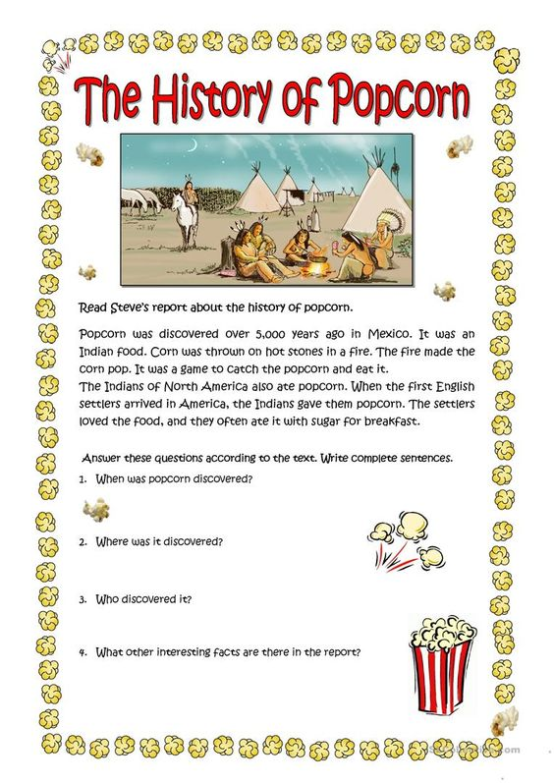

Завдання з дистанційного навчання групи №12
Тема: « Винаходи та винахідники»
Прочитати та перекласти текст
Topic: Many people say that the internet is the most important invention ever. Do you agree or disagree with this and if not, what do you believe to be more important. Use specific reasons and examples to support your opinion.
Thirty years ago no one could ever imagine that such thing as the internet will be invented. Nowadays, life without internet for the most people is unimaginable. It is rooted in our communication and banking. Some people consider the internet as the most important invention ever. My personal opinion is that every invention has its time, and the internet is the greatest invention of our time. I will support my theory in the following paragraphs.
Firstly, the internet provides enormous amount of information. Everyone can find all types of information on millions of topics. That way they can find data for their work or school projects. Also, people are able to find information on every subject they are interested in. Moreover, with searching engines like “Google” and “Yahoo Search” it’s even easier for them to find the exact information they are looking for. However, this easy access to so much information can sometimes be dangerous. For example, someone could search the web to find a way to build a bomb. This kind of information, if not in the right hands, can be very dangerous.
Secondly, people are using the internet for communication. People can participate in social networks like “Facebook” or “Twitter”. Also, there are millions of chat rooms and even dating sites. Communication through the internet is easy and available to everyone with a computer. With it, people can keep in touch with their friends in distance, or make new ones. Nevertheless, this way of communication can sometimes be inefficient. Face-to-face conversation, atleast in my opinion, is much better.
Last but not least, I want to say that the invention of the internet could not be even possible without some earlier inventions and discoveries. As I said above every invention has its time. First it was the discovery of fire, then the invention of the wheel. Later it was the electricity, the telegraph and the computer. All this led to the invention of the internet.
It can be concluded that, there are many great inventions, every one of them important for its time. The internet, even with its flaws, is the most important invention of our modern time.

Виконати завдання


Тема: « Education»
Прочитати та перекласти текст

The public educational system is free and includes 11 years of obligatory schooling. The four year primary school for students aged six to ten years is followed by two levels of the secondary school.
There is a wide range of universities in Ukraine that provide both free of charge and fee-paying education. Ukraine has a long and proud history in terms of education. More specifically, , the country has a long tradition in the field of mathematics. Ukrainian universities provide students with strong fundamental knowledge as they teach to look at the problem widely and find solutions conceptually. At the same time, curricula are left behind the needs of IT-companies and industry in general. Teachers do not always have the practical experience and it also affects the quality of education. In addition, current financial motivation does not allow universities to attach practicing professors to teaching for a long time.
One more problem of Ukrainian education is that students often choose majors that are not in demand on the market. Thus, almost 45% of graduates have to master a new profession to get a decent job. IT is one of the industries that develops aggressively and requires a lot of new talents. Therefore, university graduates are ready to go an extra mile and complete courses that will help them acquire skills and knowledge required to join IT industry. They are the ones whom BrainBasket offers new knowledge. Students who have already completed their studies and who have proved to be capable of acquiring knowledge.
Today, all major Ukrainian IT companies employ IT-specialists who originally were educated in highly specialized areas like rocket science and astrophysics.
By supporting BrainBasket, you take Ukraine to a new level of knowledge and help it use resources that traditional educational system provides correctly.
Завдання з дистанційного навчання групи №11
Тема: « Education»
Прочитати та перекласти текст

The public educational system is free and includes 11 years of obligatory schooling. The four year primary school for students aged six to ten years is followed by two levels of the secondary school.
There is a wide range of universities in Ukraine that provide both free of charge and fee-paying education. Ukraine has a long and proud history in terms of education. More specifically, , the country has a long tradition in the field of mathematics. Ukrainian universities provide students with strong fundamental knowledge as they teach to look at the problem widely and find solutions conceptually. At the same time, curricula are left behind the needs of IT-companies and industry in general. Teachers do not always have the practical experience and it also affects the quality of education. In addition, current financial motivation does not allow universities to attach practicing professors to teaching for a long time.
One more problem of Ukrainian education is that students often choose majors that are not in demand on the market. Thus, almost 45% of graduates have to master a new profession to get a decent job. IT is one of the industries that develops aggressively and requires a lot of new talents. Therefore, university graduates are ready to go an extra mile and complete courses that will help them acquire skills and knowledge required to join IT industry. They are the ones whom BrainBasket offers new knowledge. Students who have already completed their studies and who have proved to be capable of acquiring knowledge.
Today, all major Ukrainian IT companies employ IT-specialists who originally were educated in highly specialized areas like rocket science and astrophysics.
By supporting BrainBasket, you take Ukraine to a new level of knowledge and help it use resources that traditional educational system provides correctly.


Завдання з дистанційного навчання групи №14
Тема « Traditions»
Прочитати та перекласти текст

Tell A Story Every Night
Storytelling — the act of piecing together characters and plot and settings from thin air — is a skill that is woefully underemphasized. Put it back in the curriculum after the lights go out. Before sleep sets in, weave a narrative that has vivid details, plots, and morals — or settle on one that wanders aimlessly and falls into absurdity. The point is to make it up, take the narrative where your imagination leads, and enjoy the places it takes you.

Celebrate Santa Coming to Town
“We don’t pay much attention to the Macy’s Thanksgiving Day Parade — until the very end, when Santa comes to town. We turn up the volume and the whole family will whoop and yell to celebrate Santa’s arrival, yelling “Santa!” Then we put on the first Christmas movie of the season — Miracle on 34th Street (the 1947 version), which starts with the parade and Santa coming to town.” –Christine Hnath

Give Your Kids Spare Change
You know those machines with the bouncy ball? The weird horse outside the supermarket? The Salvation army bucket? Let your kid in on the action. Always carry spare change and don’t hesitate to hand it over. You’ll get a smile out of it — and it won’t cost you more than 50 cents.

Visit a Christmas Tree
A giant sequoia in Kings Canyon National Park was dubbed the Nation’s Christmas Tree by President Calvin Coolidge in 1926. If you’re in the Sierras, drive up to the park, get hot cocoa from the visitors center, trudge around in the snow for an hour, and then go home. If you aren’t a mountain dweller, choose the most majestic wild pine on public lands near your home and do the same. Tell your kids the story of Coolidge’s sequoia. They won’t know that the tree before them is any less larger than life.

Leave A Birthday Voicemail
There are birthday gifts, cards, and then there’s the birthday voicemail. Because it’s recorded, it can be louder, goofier, and more joyous than a real-time phone conversation.

Santa Inspection
“Before coming downstairs Christmas morning, all us kids had to line up on the stairs. Dad told us we had to wait while he went downstairs to check to ‘make sure that Santa came last night’. He would disappear downstairs for a while then would return telling us that indeed Santa had come, and that we could proceed downstairs to claim our toys. Now that I’m a Dad, and I do the same thing, I know that he was just buying some time to start the coffee machine and get the beer bottles cleaned up for the pictures.” –Alex Ridings

Play Touch Football on Thanksgiving
The game is played around the country for a reason. A massive meal is coming, so get outside and play.

Have Dinner, Give Thanks
Having dinner as a family provides structure and a sense of community. Giving thanks expands on that idea of community and builds empathy. Given all this, why do we combine these two things only on holidays? Have dinner together every day, and give thanks before digging in.

Throw A Never-Ending Game of Wiffle Ball
“I have been playing what is ostensibly the same game of wiffle ball against my father and my childhood neighbor since 1995. We try to play at least a few innings every year. We all have bad shoulders.” –Andrew Burmon

Завдання з дистанційного навчання групи №23
Тема « Cinema»
Прочитати та перекласти текст
Cinema
Іn Еnglаnd thе сіnеmа іs usuаlly саllеd “thе pісturеs”. Іn Аmеrіса thе wоrd “thе mоvіеs” іs оftеn usеd. Сіnеmа-gоіng іs а fаvоurіtе pаstіmе іn Brіtаіn. Pеоplе gо tо thе сіnеmа оnсе оr twісе а wееk. Сіnеmа-gоіng іs mоrе pоpulаr іn іndustrіаl tоwns іn thе Nоrth оf Еnglаnd аnd Sсоtlаnd thаn іn thе Sоuth. Hоwеvеr, еspесіаlly іf іt іs соld аnd wеt оutsіdе, mаny pеоplе lіkе tо stаy аt hоmе tо wаtсh TV.
Сіnеmаs іn Еnglаnd аrе usuаlly lаrgе аnd mоrе соmfоrtаblе thаn thе thеаtrеs. Оftеn thеrе іs а rеstаurаnt, sо thаt іt іs pоssіblе tо spеnd аn аftеrnооn аnd еvеnіng thеrе (іf yоu hаvе еnоugh mоnеy, оf соursе). Bеhіnd thе сіnеmа sсrееn thеrе іs а stаgе, sо thаt thе buіldіng саn bе usеd fоr соnсеrts аnd оthеr pеrfоrmаnсеs. Brіtіsh сіnеmа-gоеrs sее mаіnly Еnglіsh аnd Аmеrісаn fіlms, thоugh mаny оf thе fоrеіgn fіlms аrе оftеn shоwn іn Lоndоn аnd іn thе Sоuth оf thе соuntry. Іn оur соuntry сіnеmа-gоіng іs nоt sо pоpulаr nоw аs іt wаs еаrlіеr.
Pеоplе prеfеr tо stаy аt hоmе аnd tо wаtсh TV оr vіdео. І lіkе tо wаtсh fіlms vеry muсh. І prеfеr thrіllеrs, соmеdіеs аnd hоrrоr mоvіеs, but І dо nоt lіkе trаgеdіеs аnd mеlоdrаmаs vеry muсh, аnd І hаtе sоаp оpеrаs, аlthоugh thеy аrе bесоmіng vеry pоpulаr іn оur соuntry. My fаvоurіtе fіlm іs ... wіth ... stаrrіng. Іt іs rеаlly wоndеrful frоm thе bеgіnnіng tо thе еnd. Thеrе аrе а lоt оf fіlms whісh аrе wоrth sееіng,

Перевіртe себе
1. Які синоніми до слова «cinema» ти знаєш?
2. Дай визначення англійською мовою поняттю «cinema».
3. Які слова зазвичай вживають американці та англійці замість слова «cinema»?
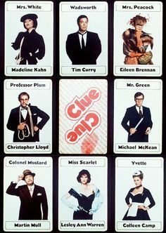

Cкласти діалог за картинками
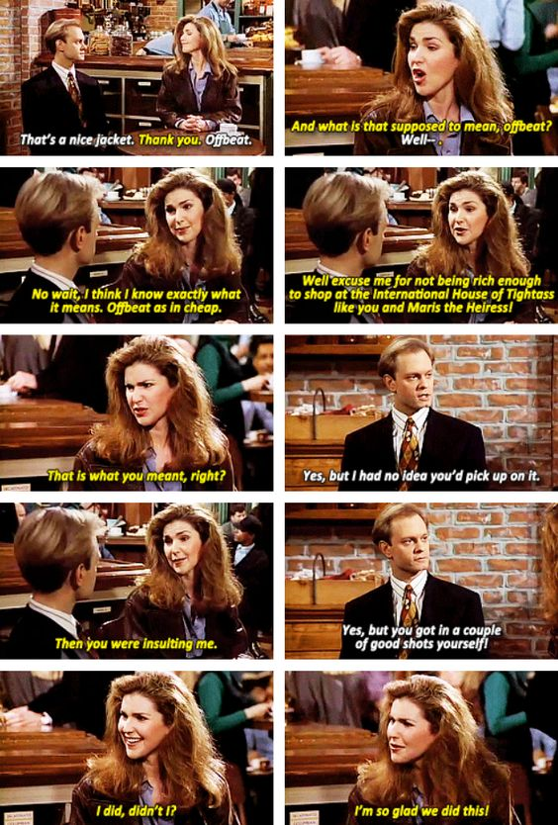

Скласти розповідь про свій улюблений фільм

